**12/23/2021-12/25/2021:**

Also got some results regarding hyperparameter tuning the ResNet Model

| Key: Date: 20211226-133808 = year|month|day–|hour|minute|seconds = December 26, 2021 at 1:38:08 p.m. | | | |
| --- | --- | --- | --- |
| o= optimizer  lr = learning rate  f = factor | p= patience  min_lr = minimum learning rate  NE = number of epochs | BS = batch size  d = depth  D = duration (seconds) | A = accuracy(percents)  P = precision (percents)  R= recall (percents)  F1 = f1 score (percents) |

| Trial | o | lr | f | p | min_lr | NE | BS | A | P | R | F1 | D |
| --- | --- | --- | --- | --- | --- | --- | --- | --- | --- | --- | --- | --- |
| 20211222-113235 | Adam | 0.002 | 0.5 | 50 | 0.0001 | 500 | 64 | 57.70% | 57.32% | 57.71% | 56.06% | 1748 |
| 20211224-093659 | Adam | 0.005 | 0.5 | 40 | 0.0001 | 200 | 64 | 60.21% | 59.34% | 60.21% | 58.62% | 704 |
| 20211225-205446 | Adam | 0.009 | 0.5 | 50 | 0.0001 | 400 | 64 | 63.21% | 63.90% | 63.21% | 61.55% | 1443 |

I did more analysis on why some subjects were predicted correctly more than others.

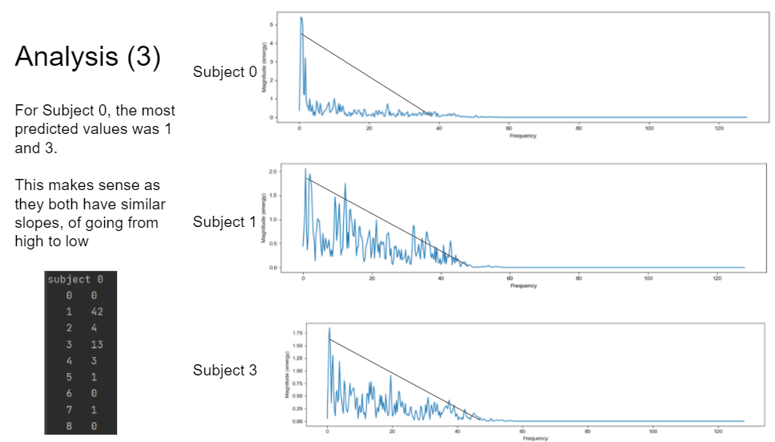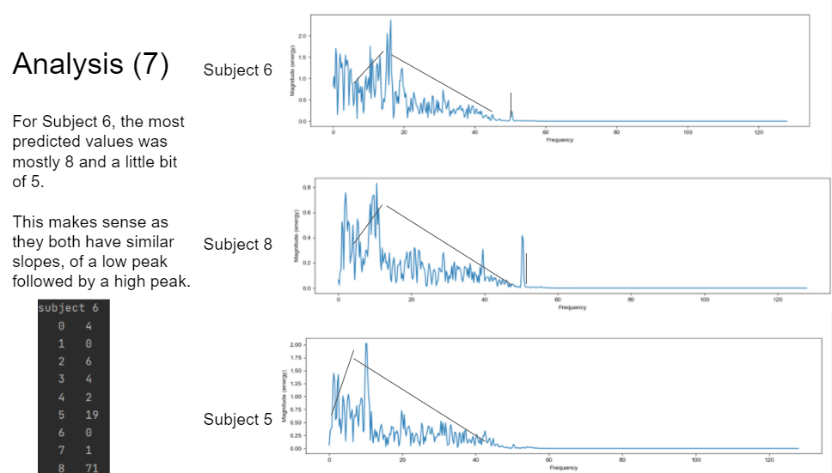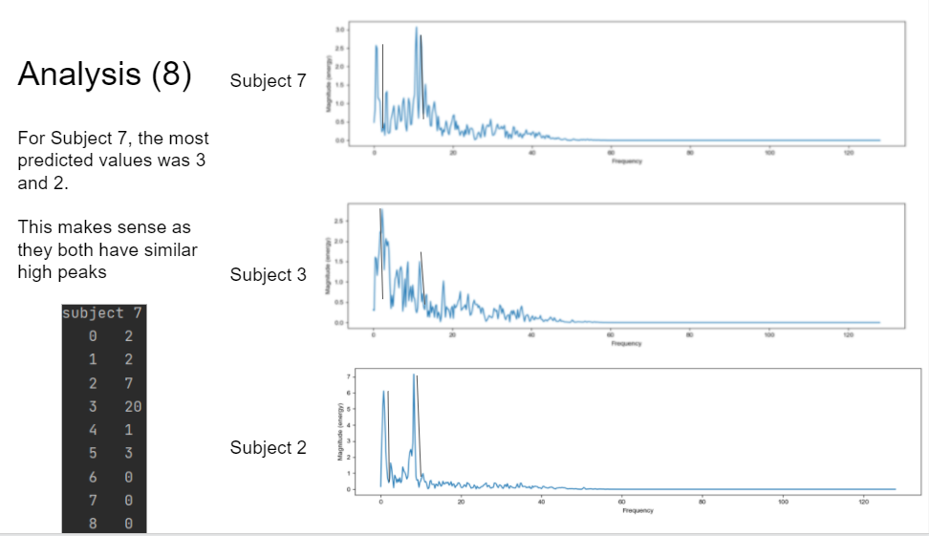

**12/26/2021:**

Learned about the Inception Model. Implemented it and also did hyperparameter tuning on it.

| Trial | o | lr | f | p | min_lr | NE | BS | d | A | P | R | F1 | D |
| --- | --- | --- | --- | --- | --- | --- | --- | --- | --- | --- | --- | --- | --- |
| 20211226-133808 | Adam | 0.001 | 0.5 | 50 | 0.0001 | 500 | 64 | 6 | 67.67% | 70.24% | 67.61% | 67.47% | 610 |
| 20211226-142022 | Adam | 0.002 | 0.5 | 10 | 0.0001 | 150 | 64 | 6 | 68.64% | 73.92% | 68.57% | 67.93% | 605 |
| 20211226-150013 | Adam | 0.003 | 0.5 | 10 | 0.0001 | 150 | 64 | 6 | 70.18% | 74.22% | 70.14% | 69.87% | 646 |

**1/08/2022:**

Read the paper, *EEGNet: a compact convolutional neural network for EEG-based brain–computer interfaces*. Learned about the EEGNet, another deep learning model. It is used for BCI applications so I will have to modify it for subject identification. Key points: uses a temporal convolution to learn frequency filters, then a depthwise convolution to learn frequency-specific spatial filters, and finally a separable convolution (combination of depthwise convolution and pointwise convolution), which first gets a temporal summary for each feature map and then optimally mix the feature maps together.

**1/15/2022:**

Implemented EEGNet and got initial results for EEGNet: Accuracy: 80.25% , Precision: 84.94% , Recall: 80.27% , F1 score: 78.27%

**1/20/2022:**

Talked to Khuong Vo and he advised me to get the average and variance of the inference durations(time to run through the test set) and training durations to see the practically of these deep learning models, because the model will have to also not only be good but also fast as well when testing the EEG-based biometric system in real-time.

**1/24/2022:**

Got the average and variance of the inference durations as well as the training duration.

These are the respective training times:

Inception: 645.5973 seconds

ResNet: 1443.451 seconds

EEGNet: 140.7042.

These are the inference times:

Inception: Average: 0.32123104731241864, Variance: 0.00008348036295855

ResNet: Average: 0.4459923267364502, Variance: 0.0004393475894691315

EEGNet: Average: 1.232327938079834, Variance: 0.004648799106500216

**2/07/2022:**

Meeting with my mentors about my current results. Decided to read the paper, *Deep learning for electroencephalogram (EEG) classification tasks: a review*, for better understanding of the deep learning models currently being used to see how I can improve my deep learning models and data preprocessing algorithms.